**Tourism Management System**

Software Requirements Specification

31 October 2023

Nalla Bhargav Thirupathi Rao

12111609

Prepared for

Continuous Assessment 3

Autumn 2023

# Revision History

|  |  |  |  |
| --- | --- | --- | --- |
| **Date** | **Description** | **Author** | **Comments** |
| 15-10-2023 | Version 1 | Bhargav Nalla | Added Definitions Section |
| 18-10-2023 | Version 2 | Bhargav Nalla | Included References |
| 21-10-2023 | Version 3 | Bhargav Nalla | Updated Introduction |
| 24-10-2023 | Version 4 | Bhargav Nalla | Completed Test Plan |
| 27-10-2023 | Version 5 | Bhargav Nalla | Added Acceptance Criteria |
| 30-10-2023 | Version 6 | Bhargav Nalla | Final Review and Updates |

**Table of Contents**

Revision History 2

CLIENT Approval Error! Bookmark not defined.

1. Introduction Error! Bookmark not defined.

1.1 Purpose **Error! Bookmark not defined.**

1.2 Scope **Error! Bookmark not defined.**

1.3 Definitions, Acronyms, and Abbreviations **Error! Bookmark not defined.**

1.4 References **Error! Bookmark not defined.**

1.5 Overview **Error! Bookmark not defined.**

2. General Description Error! Bookmark not defined.

2.1 Product Perspective **Error! Bookmark not defined.**

2.2 Product Functions **Error! Bookmark not defined.**

2.3 User Characteristics **Error! Bookmark not defined.**

2.4 General Constraints **Error! Bookmark not defined.**

2.5 Assumptions and Dependencies **Error! Bookmark not defined.**

3. Specific Requirements Error! Bookmark not defined.

3.1 External Interface Requirements **Error! Bookmark not defined.**

3.1.1 User Interfaces **Error! Bookmark not defined.**

3.1.2 Hardware Interfaces **Error! Bookmark not defined.**

3.1.3 Software Interfaces **Error! Bookmark not defined.**

3.1.4 Communications Interfaces **Error! Bookmark not defined.**

3.2 Functional Requirements **Error! Bookmark not defined.**

3.2.1 <Functional Requirement or Feature #1> **Error! Bookmark not defined.**

3.2.2 <Functional Requirement or Feature #2> **Error! Bookmark not defined.**

3.5 Non-Functional Requirements **Error! Bookmark not defined.**

3.5.1 Performance **Error! Bookmark not defined.**

3.5.2 Reliability **Error! Bookmark not defined.**

3.5.3 Availability **Error! Bookmark not defined.**

3.5.4 Security **Error! Bookmark not defined.**

3.5.5 Maintainability **Error! Bookmark not defined.**

3.5.6 Portability **Error! Bookmark not defined.**

3.7 Design Constraints **Error! Bookmark not defined.**

3.9 Other Requirements **Error! Bookmark not defined.**

4. Analysis Models Error! Bookmark not defined.

4.1 Data Flow Diagrams (DFD) **Error! Bookmark not defined.**

A. Appendices Error! Bookmark not defined.

A.1 Appendix 1 **Error! Bookmark not defined.**

A.2 Appendix 2 **Error! Bookmark not defined.**

1.Introduction:

As we know that online travel and tour business is growing rapidly so travel websites will be more friendly. In this project user can easily understand and book all packages and also register for hotels. In this, various packages are available, room registration, booking option page so that user can insert all their needs and facilities &the upload the form by which they can be registered in the booking page. This site provides different packages like hill station, metropolis, beaches and hotel booking services in particular state of India. And more the user can book different types of rooms (AC, non -AC, jostle, etc.). For online payment the user can use suitable mode like credit/debit card, UPI transaction, net banking. And for cancellation of booking there will be no charge and will get 100% refund if you cancel within 24 hours the amount will be credited to users account within 4-5 working days.

* 1. **Purpose**

The Tours and Travel Management System is a software solution designed to streamline and enhance the management and booking processes for tour operators and travelers. This system aims to provide an efficient and user-friendly platform for customers to explore, select, and reserve tours, as well as for administrators to manage tours, bookings, and customer information. This document outlines the software requirements that will guide the development and implementation of this system.

* 1. **Scope**
* The Tours and Travel Management System is envisioned to serve the needs of both customers and administrators in the travel and tourism industry. Its primary features will include:
* User Management: User registration and login for customers and administrators.
* Tour Management: Listing and booking tours, along with tour creation and management by administrators.
* Payment Processing: Secure online payment handling for tour reservations.
* Booking Management: Management and cancellation of bookings.
* User Profiles: Customer and administrator profiles for managing personal information.
* Reporting: Generating reports related to tour bookings and financial data.
* The system will be designed to operate in a web-based environment, offering accessibility across various devices and web browsers. It will not only enhance the customer experience but also provide valuable tools for tour operators to efficiently manage their offerings and gain insights into their business.
  1. **Objectives**
* The primary objectives of the Tours and Travel Management System are as follows:
* To provide a user-friendly and intuitive interface for customers to explore and book tours.
* To offer administrators the tools necessary to efficiently manage tours and bookings.
* To ensure the security and privacy of user data and financial transactions.
* To enhance the efficiency and reliability of the tour booking process.
* To enable tour operators to generate reports that provide insights into their business performance.

**1.3 Definitions, Acronyms, and Abbreviations**

* SRS: Software Requirements Specification, a document that outlines the functional and non-functional requirements of a software system.
* UI: User Interface, the visual and interactive elements that users interact with.
* UX: User Experience, the overall experience of a user while interacting with the application.
* API: Application Programming Interface, a set of rules that allow one software application to interact with another.
* JSON: JavaScript Object Notation, a lightweight data-interchange format.
* HTML: HyperText Markup Language, the standard markup language for creating web pages.
* CSS: Cascading Style Sheets, a stylesheet language used for describing the look and formatting of a document written in HTML.
* HTTP: Hypertext Transfer Protocol, the foundation of data communication on the World Wide Web.
* URL: Uniform Resource Locator, a reference used to access resources on the internet.
* DBMS: Database Management System, software for managing databases.
* MVP: Minimum Viable Product, the simplest version of a product that can be developed and deployed to gain user feedback.
* CLI: Command Line Interface, a text-based interface for interacting with a computer program.
* UX/UI Design: User Experience/User Interface Design, the process of creating the visual and interactive elements of the application to optimize user satisfaction.
  1. **References**

This section should list any external documents, standards, or resources that were used as references during the development of the project. Since this is a fictional project, you may not have actual references, but you can create placeholder entries like:

• "Web Development Best Practices" by John Doe

• "Bootstrap Documentation" - https://getbootstrap.com/docs

• "Spotify API Documentation" - https://developer.spotify.com/documentation/webapi/

• HTML and CSS Standards" - https://www.w3.org/standards/

**1.6 Revision History**

This section should document the history of revisions made to the SRS, including the date and a brief summary of changes for each revision. Here's an example of how this section might look initially:

• **Revision 1.0 (01-10-2023)**

Initial draft of the SRS.

• **Revision 1.1 (03-10-2023)**

Added Definitions, Acronyms, and Abbreviations section.

Included References section with placeholder entries.

**• Revision 1.2 (05-10-2023)**

Incorporated feedback on the introduction.

Added placeholders for the remaining sections of the SRS.

• **Revision 1.3 (10-10-2023)**

Completed the Home Page section with detailed requirements.

Updated the Scope section to include additional features.

• **Revision 1.4 (15-10-2023)**

Added the pakages section with functional and non-functional

Clarified user roles in the User Profiles section.

**• Revision 1.5 (20-10-2023**)

Included specific security requirements in the

User Authentication section

Expanded the References section with actual

documents and resources used.

• **Revision 1.6 (25-10-2023)**

Updated the Introduction with a more detailed project overview.

Added placeholders for the Test Plan and

Acceptance Criteria sections.

• **Revision 1.7 (30-10-2023)**

Completed the Test Plan section, outlining testing strategies and criteria.

Added initial content to the Acceptance Criteria section.

This section will help keep track of the document's evolution as it undergoes reviews and updates during the project's development. Make sure to update it as you make revisions to the SRS.

**2**. **General Description**

This section of the SRS should describe the general factors that affect 'the product and its requirements. It should be made clear that this section does not state specific requirements; it only makes those requirements easier to understand.

**2.1 Product Perspective**

The Tours and Travel Management System is a self-contained software solution that operates independently. It does not rely on or interface directly with other external systems or software. However, it assumes that it will be deployed on a standard web server and interact with a compatible database management system (DBMS) for data storage and retrieval.

**2.2 Product Functions**

The primary functions of the Tours and Travel Management System include:

* User Registration and Login: Allow customers to create accounts and log in. Enable administrators to access the system securely.
* Tour Management: Provide customers with the ability to browse and select tours. Administrators can create, modify, and remove tour listings.
* Payment Processing: Facilitate secure online payments for tour reservations.
* Booking Management: Allow customers to manage their bookings, and enable administrators to oversee and modify bookings.
* User Profiles: Let customers and administrators view and update their profiles.
* Reporting: Generate reports for administrators to gain insights into booking statistics and financial data.

**2.3 User Characteristics**

The Tours and Travel Management System caters to two primary user roles:

* Customers: These users are individuals interested in browsing and booking tours. They have basic computer literacy and expect an easy-to-navigate interface.
* Administrators: These users manage the system and its data. They have a deeper understanding of the system's functionality and require tools for managing tours, bookings, and customer information.

**2.4 General Constraints**

The system must adhere to several general constraints:

* Technology Stack: The system will use HTML, CSS, JavaScript, and Bootstrap for the front-end. The choice of the back-end technology stack is yet to be defined.
* Legal Compliance: The system must comply with all relevant laws and regulations in the regions where it operates, including data protection and privacy laws.

**2.4 General Constraints**

* The system must adhere to several general constraints:
* Technology Stack: The system will use HTML, CSS, JavaScript, and Bootstrap for the front-end. The choice of the back-end technology stack is yet to be defined.
* Legal Compliance: The system must comply with all relevant laws and regulations in the regions where it operates, including data protection and privacy laws.

**2.5 Assumptions and Dependencies**

Several key assumptions and dependencies influence the development and operation of the Tours and Travel Management System:

* Database System: The system assumes a compatible database management system (e.g., MySQL, PostgreSQL) will be available for data storage and retrieval.
* Payment Gateway Service: It depends on a reliable third-party payment gateway service for secure payment processing.
* Web Hosting: The system will be deployed on a web server or cloud hosting infrastructure, assuming reliable hosting services are available.
* User Internet Access: Users are assumed to have access to the internet for system usage.
* Legal Compliance: The system assumes that legal and regulatory compliance is maintained by the organization using it, including adhering to data protection and privacy laws.
* These assumptions and dependencies will be essential considerations throughout the development and deployment of the system.
* These sections provide an overview of the product perspective, functions, user characteristics, general constraints, and assumptions and dependencies for the Tours and Travel Management System. Adjust and expand these sections as needed to accurately describe your project.

**3. External Interface Requirements**

**3.1 User Interfaces**

* The user interfaces for the Tours and Travel Management System include web-based interfaces for both customers and administrators.
* These interfaces should be designed for easy navigation and a pleasant user experience.

**3.1.1 Customer Interface**

* The customer interface allows users to register, log in, browse tours, make reservations, and manage their profiles.
* It features a user-friendly design with responsive layouts to accommodate different devices and screen sizes.
* Customer interfaces must support various browsers, including Chrome, Firefox, Safari, and Edge.

**3.1.2 Administrator Interface**

* The administrator interface enables staff to manage tours, bookings, customer information, and generate reports.
* Admin interfaces are accessible through secure login procedures.
* These interfaces are optimized for desktop or tablet usage.

**3.1.3 Hardware Interfaces**

* The Tours and Travel Management System does not require direct hardware interfaces. It will run on standard hardware configurations suitable for web-based applications, including web servers and database servers.

**3.1.4 Software Interfaces**

The software interfaces for the system include interactions with external components and services, including:

**3.1.4.1 Payment Gateway**

* The system must integrate with a secure third-party payment gateway service for processing online payments.

3.1.4.2 Maps and Geolocation Services

* To provide tour location information, the system may interface with mapping and geolocation services (e.g., Google Maps API).

3.1.4.3 Database Management System

The system will interact with a database management system (e.g., MySQL, PostgreSQL) for data storage and retrieval.

**3.1.5 Communications Interfaces**

* The system will rely on standard web communication protocols, including HTTP and HTTPS, for data transmission between clients and the server.

**User Registration and Login**: Customers can register for an account by providing personal information and subsequently log in using their credentials. These processes are straightforward and user-friendly.

**Tour Listings**: Customers can browse available tours and filter them based on location, date, and price. The interface provides an intuitive and visually appealing way to view tour options.

**Tour Details:** Customers can access detailed information for each tour, including pricing, duration, and the itinerary. The interface ensures that the information is presented clearly and comprehensively.

**Booking Tours:** Customers can easily select tours, specify the number of participants, and make reservations. The system ensures that customers do not overbook tours.

**User Profile:** Customers can view and update their personal information and preferences, ensuring a personalized experience.

**3.2 Functional Requirements**

**3.2.1 Tour Management**

**3.2.1.1 Introduction**

The Tour Management functionality allows users to view, search for, and book tours. Administrators can add, modify, or remove tours.

**3.2.1.2 Inputs**

* For Customers: User inputs include search criteria (location, date, price) and booking details (number of participants).
* For Administrators: User inputs include tour details (location, date, price) and modifications to existing tours.

**3.2.1.3 Processing**

* The system processes user input to fetch relevant tour information, validate bookings, and update tour data.

**3.2.1.4 Outputs**

* Customers receive tour listings, detailed tour information, and booking confirmations.
* Administrators see updated tour details and booking information.

**3.2.1.5 Error Handling**

* The system must handle errors such as invalid input, failed bookings, and system errors gracefully. Clear error messages and user notifications are necessary.

**3.2.2 User Registration and Login**

[Continue this format for other functional requirements or features...]

**3.5 Non-Functional Requirements**

**3.5.1 Performance**

Performance requirements ensure that the system functions optimally.

**3.5.1.1 Response Time**

* The system should respond to user actions within a maximum of 2 seconds.
* Tour listings should load in under 3 seconds.

**3.5.1.2 Scalability**

* The system should support up to 1000 simultaneous users without significant performance degradation.
* Tour database should handle up to 10,000 tours.

**3.5.2 Reliability**

* The system must maintain data integrity and operate reliably.

**3.5.2.1 Data Backup**

* Data should be regularly backed up to prevent data loss.

**3.5.3 Availability**

* The system should be available 99.9% of the time.

**3.5.4 Security**

* The system must ensure data and transaction security.

**3.5.4.1 User Data Encryption**

* User passwords and payment information should be stored securely and encrypted.

**3.5.5 Maintainability**

* The system should be easily maintainable.

**3.5.5.1 Code Documentation**

* Code should be well-documented to facilitate maintenance and future development.

**3.5.6 Portability**

* The system should be accessible across various devices and browsers.

**3.7 DESIGN CONSTRAINTS**

* The design of the Tours and Travel Management System is subject to several constraints that are essential to consider during the development and implementation phases. These constraints help guide the system's architecture, technology choices, and overall design.

**3.7.1 Technology Stack**

The choice of technology stack for the Tours and Travel Management System has certain constraints:

**Front-End Technologies:** The front-end of the system will be developed using HTML, CSS, JavaScript, and Bootstrap. These technologies are chosen for their compatibility with web browsers and their ability to provide a responsive and visually appealing user interface.

**3.7.3 Performance and Scalability**

The system's design must consider performance and scalability constraints:

**Performance:** The system should be designed to meet performance requirements, ensuring that user interactions are responsive. Response times for various functions, such as tour listing and payment processing, should not exceed predefined limits.

**Scalability:** The system should be architected with scalability in mind, capable of accommodating an increasing number of users and a growing database of tours and customer data.

**3.7.4 Usability and Accessibility**

The system's design should prioritize usability and accessibility:

**Usability:** User interfaces must be intuitive, well-organized, and provide an enjoyable user experience. Design choices should consider user feedback and industry best practices.

**Accessibility:** The system should be accessible to users with disabilities, complying with the Web Content Accessibility Guidelines (WCAG) to ensure that all users can access and use the platform.

**3.7.5 Compatibility**

* The system's design should take into account compatibility with various browsers and devices. User interfaces should function consistently and effectively across different web browsers, including but not limited to Chrome, Firefox, Safari, and Edge. Additionally, the design should ensure a responsive layout that adapts to various screen sizes and resolutions.
* These design constraints play a critical role in shaping the architecture and functionality of the Tours and Travel Management System, ensuring that it meets user expectations, legal requirements, and performance standards.
* This section provides an overview of the design constraints that will influence the architecture and development of the Tours and Travel Management System. You can expand upon and provide more specific details as needed based on the unique requirements of your project.

**4.1 Data Flow Diagrams (DFD)**

**Drawing the Data Flow diagrams at level 0 and level 1.**

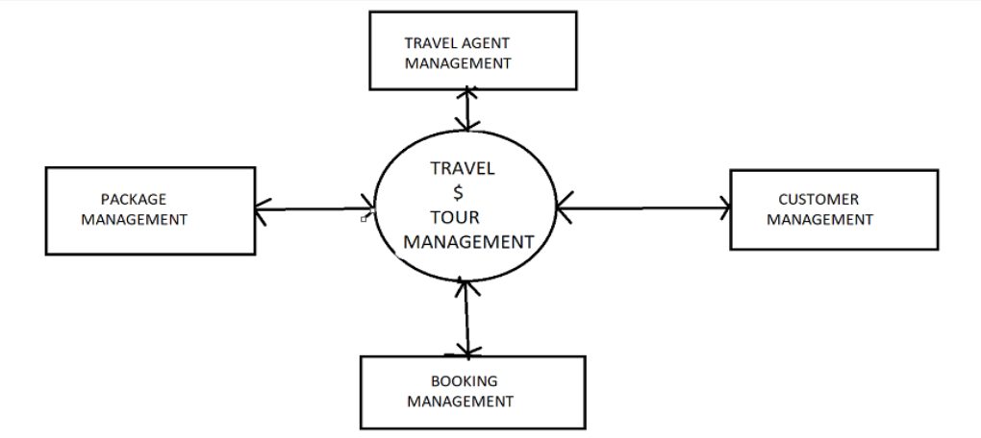

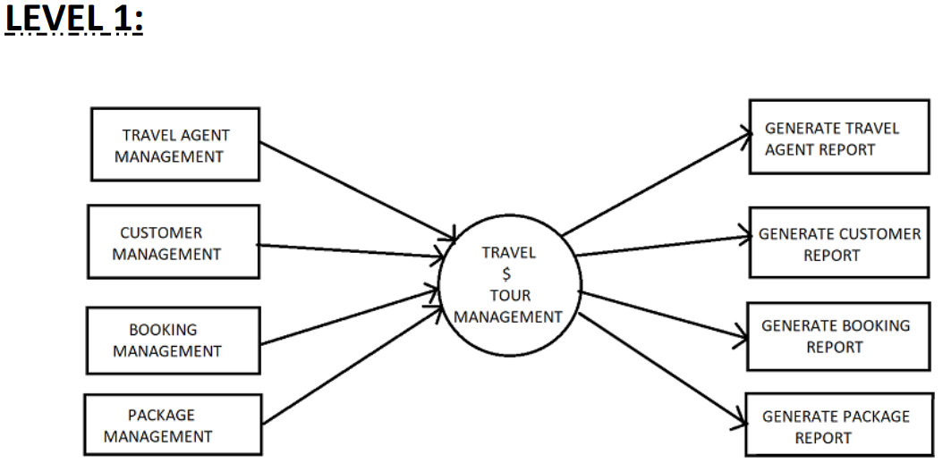

**- Drawing use case diagram**.

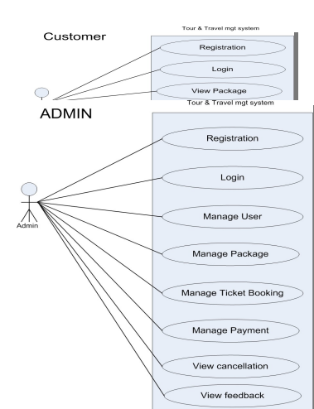

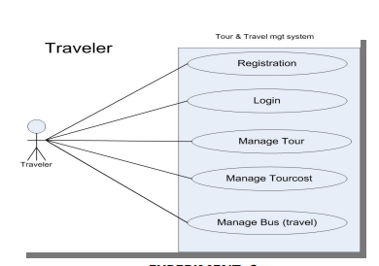

**Drawing State Chart Diagram of all use cases.**

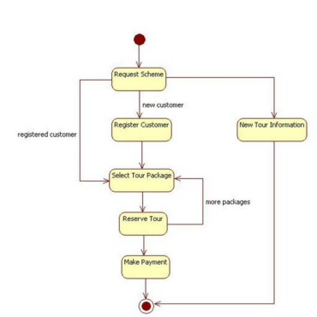

**SCREENSHOTS:**

**HOME PAGE**



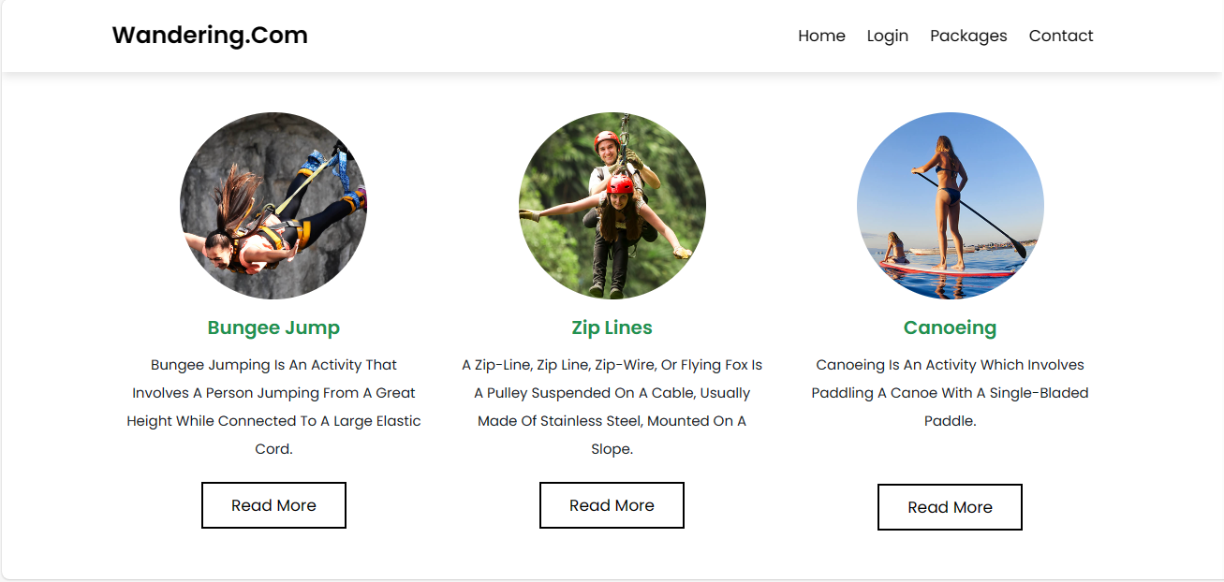

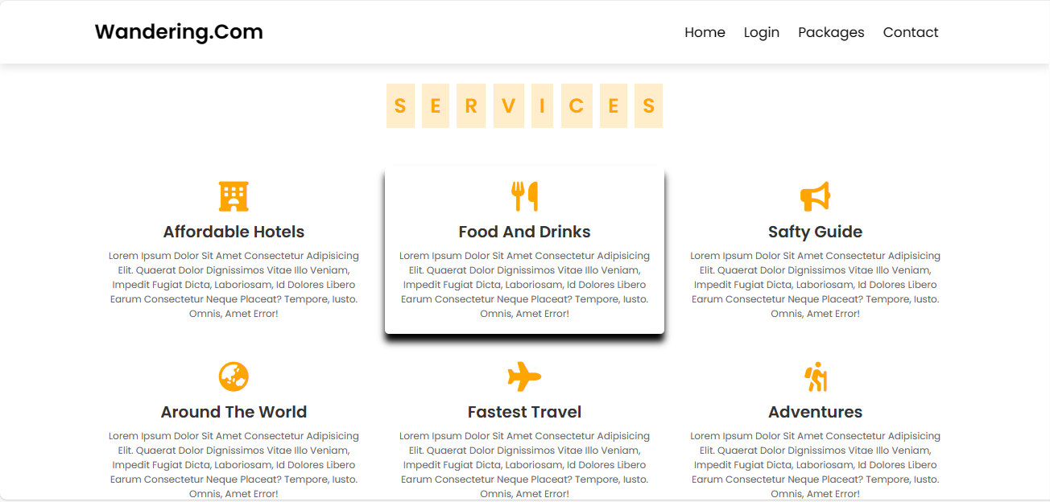

**Pakages Module**

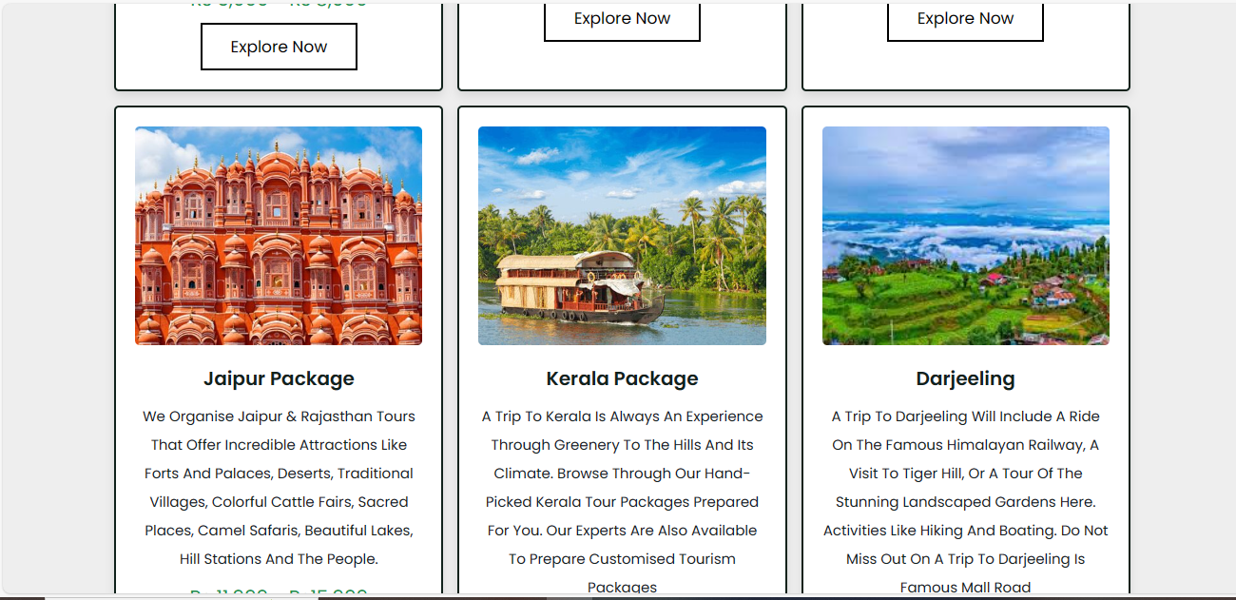



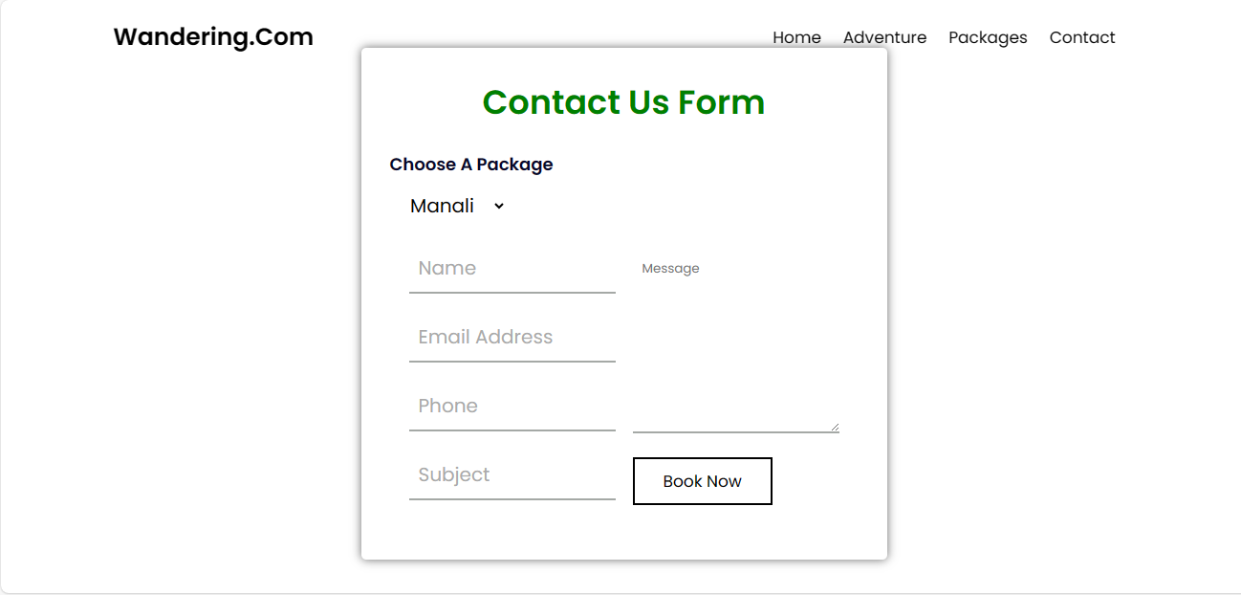

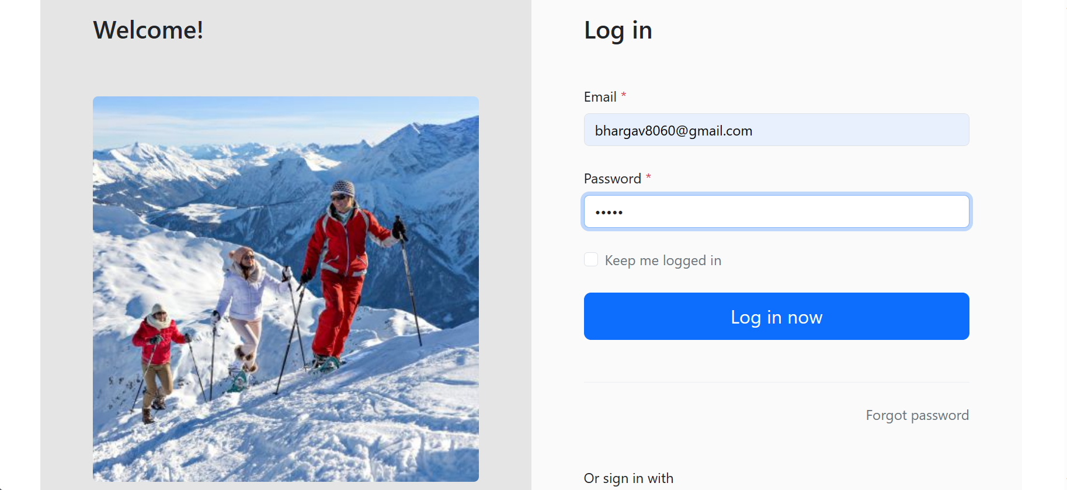

**Github Link:**

<https://github.com/Bhargav0326/Travelling-and-Tourism->

**---The End---**

**Client Approval Letter**

This Client and Developer Agreement ("Agreement") is entered into on 2nd Sep,2023, by and between:

Developer

Nalla Bhargav Thirupathi Rao

Travel-and-Tourism

Vijayawada ,521403

 And

Client:Srinu

Vijayawada,512403

Contact Information: 9866944312

Dear Srinu,

I am delighted to inform you that we are commencing work on the development of our Travel-and-Tourism website, ”Wandering.Com”. This letter marks the official beginning of the project, and we are excited to collaborate with you to create an exceptional online platform for your travel and tourism needs.

Over the coming months, our dedicated team will be working diligently to design and build a website that goes above and beyond your expectations. Our objective is to provide a comprehensive range of features, a user-friendly booking process, and an intuitive interface to make travel planning effortless and enjoyable.

Key features we plan to incorporate into the website include:

- Comprehensive destination guides

- An easy-to-navigate booking system

- User reviews and recommendations

- Interactive maps and personalized itineraries

We are committed to making this project a success, and your input is invaluable. Throughout the development process, we will keep you informed about our progress and milestones. We also welcome any ideas or suggestions you may have along the way to ensure the website aligns perfectly with your vision.

We are confident that Wandering.Com will become a premier platform for traveller’s seeking a seamless and enjoyable travel experience. Our team is dedicated to making this project a resounding success, and we look forward to collaborating with you closely.

Thank you for entrusting us with this project. If you have any questions or require any further information at any point during the project, please do not hesitate to reach out to us. We are enthusiastic about embarking on this journey with you and are committed to delivering a website that meets and exceeds your expectations.

Warm regards,

Nalla Bhargav                                                                                                                       Client Signature

Contact Information:9676723600                                                                                    